1. Buat halaman baru dan buat sebuah galeri yang menampilkan gambar gambar dalam bentuk grid!
2. Gunakan Gridview saat pembuatan soal no 1!

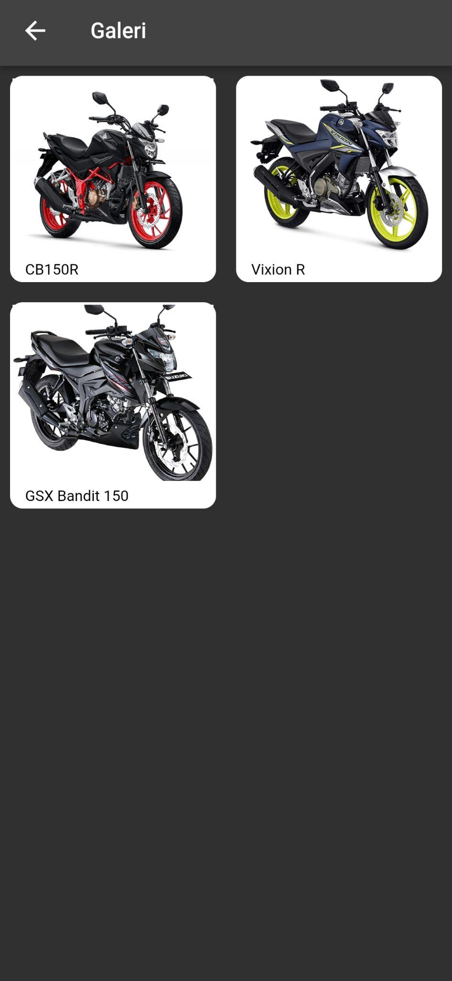

1. buatlah agar setiap gambar dapat ditampilkan pada bottomsheet saat ditekan
2. Buat agar tiap gambar pada bottomsheet dapat ditampilkan pada dialog saat ditekan
3. Pada dialog, berikan 2 pilihan ya & tidak. Jika memilih ya maka akan masuk ke halaman baru dan jika memilih tidak akan menutup dialog

* Gambar 1

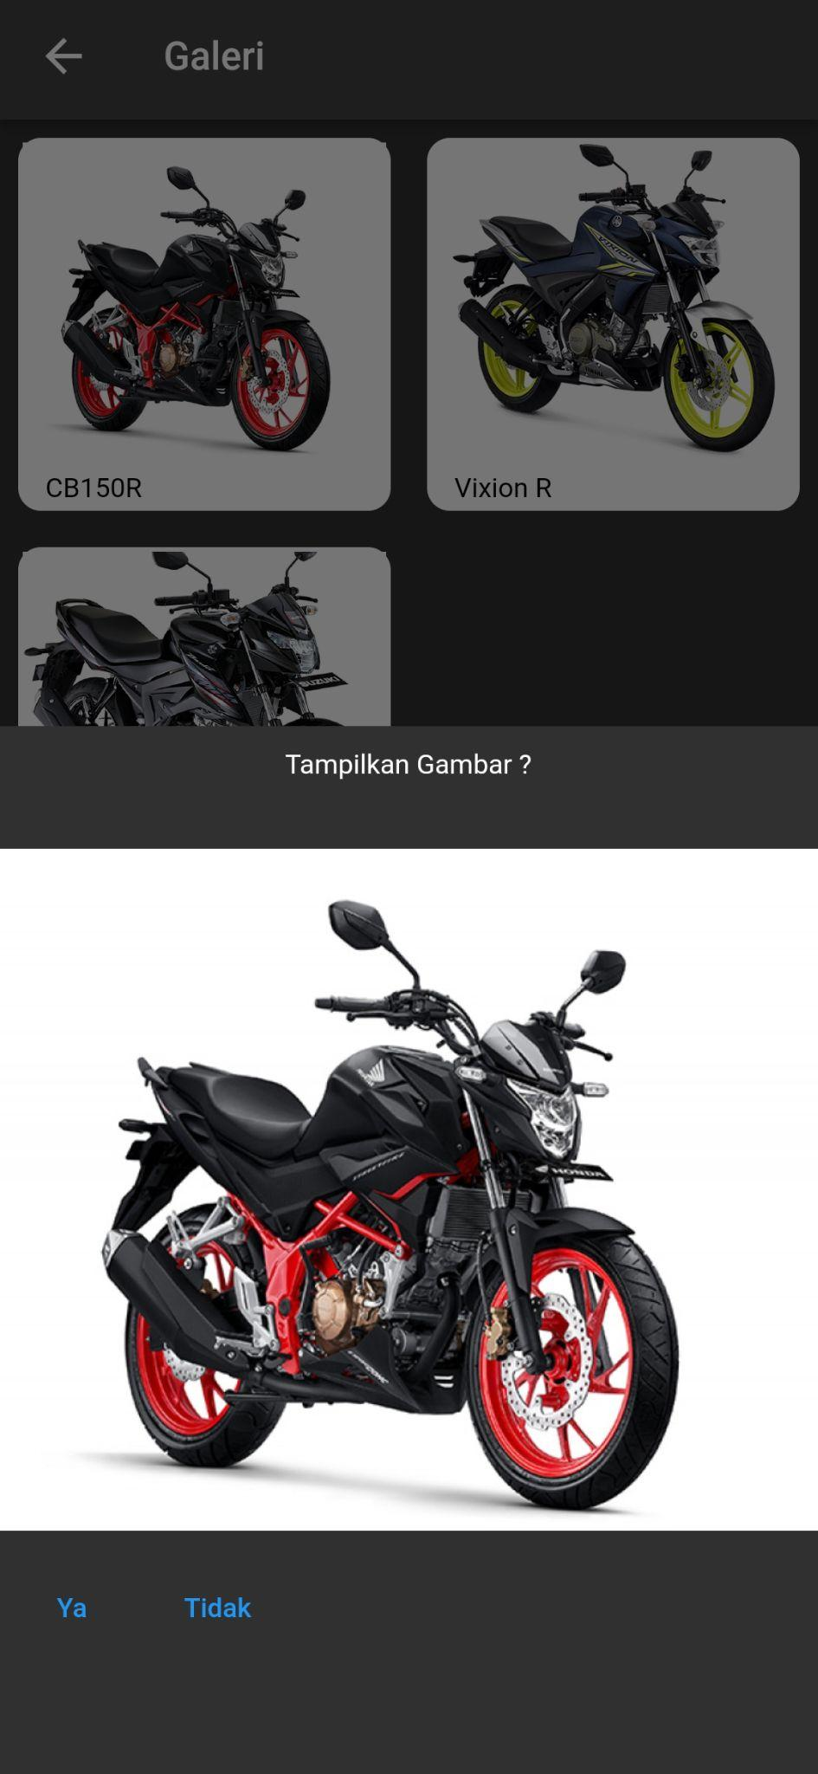

* Gambar 2

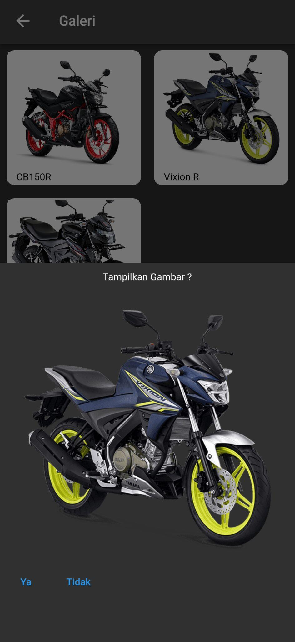

* Gambar 3

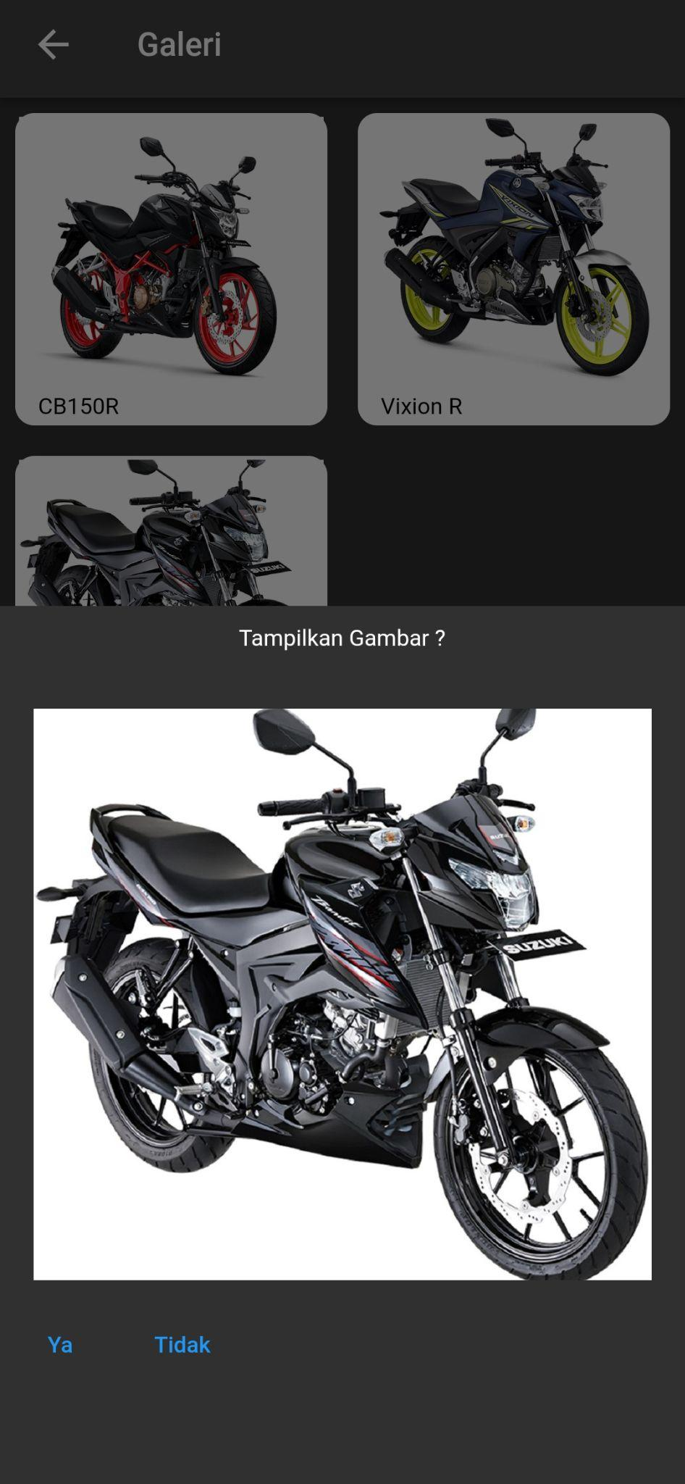

* GridviewModel.dart.

class GridviewModel{

final String title;

final String image;

GridviewModel({required this.title, required this.image});

}

final List<GridviewModel> gridviewList = [

GridviewModel(title: "CB150R", image: "https://www.fifgroup.co.id/uploads/images/large/1556011428-4ed49-cb150r.jpg"),

GridviewModel(title: "Vixion R", image: "https://www.yamaha-motor.co.id/uploads/products/new_product_model_image/202201110944359935S19728.png"),

GridviewModel(title: "GSX Bandit 150", image: "https://s3.bukalapak.com/uploads/content_attachment/8cd19f39a0216b800a85a6b5/original/Suzuki-Bandit-Black1.jpg")

];

* ImageGridviewPage.dart

import 'package:flutter/material.dart';

import 'package:flutter_platform_widget/Assets-Dialog-Bottomsheet-Navigation/GridviewModel.dart';

import 'package:flutter_platform_widget/Assets-Dialog-Bottomsheet-Navigation/ShowImagePage.dart';

class ImageGridviewPage extends StatelessWidget {

const ImageGridviewPage({Key? key}) : super(key: key);

void showImage(BuildContext context, String imagePath) {

Navigator.push(

context,

MaterialPageRoute(builder: (_) => ShowImagePage(imagePath: imagePath)),

);

}

@override

Widget build(BuildContext context) {

return Scaffold(

appBar: AppBar(

title: const Text('Galeri'),

),

body: GridView.builder(

itemCount: gridviewList.length,

gridDelegate: const SliverGridDelegateWithFixedCrossAxisCount(

crossAxisCount: 2,

),

itemBuilder: (BuildContext context, int index) {

return GestureDetector(

onTap: () {

showModalBottomSheet(

context: context,

builder: (BuildContext context) {

return Container(

margin: const EdgeInsets.only(top: 10),

height: 500,

child: Column(

children: [

const Center(

child: Text('Tampilkan Gambar ?'),

),

const SizedBox(

height: 30,

),

SizedBox(

height: 300,

child: Image.network(

gridviewList[index].image,

fit: BoxFit.cover,

)),

const SizedBox(

height: 10,

),

Row(

children: [

TextButton(

onPressed: () {

showImage(

context, gridviewList[index].image);

},

child: const Text('Ya'),

),

TextButton(

onPressed: () {

Navigator.of(context).pop();

},

child: const Text('Tidak'),

),

],

)

],

),

);

});

},

child: Padding(

padding: const EdgeInsets.all(8.0),

child: Container(

width: 154,

padding: const EdgeInsets.all(2),

decoration: const BoxDecoration(

color: Colors.white,

borderRadius: BorderRadius.all(Radius.circular(10)),

),

child: Column(

children: [

Container(

width: double.infinity,

decoration: const BoxDecoration(

borderRadius: BorderRadius.all(Radius.circular(10)),

),

child: SizedBox(

width: 140,

height: 140,

child: Image.network(

gridviewList[index].image,

fit: BoxFit.cover,

),

),

),

const SizedBox(height: 5),

Row(

children: [

Expanded(

child: Padding(

padding: const EdgeInsets.only(left: 10),

child: Text(

gridviewList[index].title,

style: const TextStyle(color: Colors.black),

),

),

),

],

)

],

),

),

),

);

},

));

}

}

* ShowImagePage.dart

import 'package:flutter/material.dart';

import 'package:flutter/src/foundation/key.dart';

import 'package:flutter/src/widgets/framework.dart';

class ShowImagePage extends StatelessWidget {

// const ShowImagePage({Key? key}) : super(key: key);

final String imagePath;

ShowImagePage({required this.imagePath});

@override

Widget build(BuildContext context) {

return Scaffold(

appBar: AppBar(

title: const Text('Image'),

centerTitle: true,

),

body: Center(

child: Image.network(imagePath),

),

);

}

}